|  |
| --- |
| How to Enter Time into CYSH |

1. Go to CYSH via your [Okta Homepage](https://cityyear.okta.com/app/UserHome) (cityyear.okta.com)

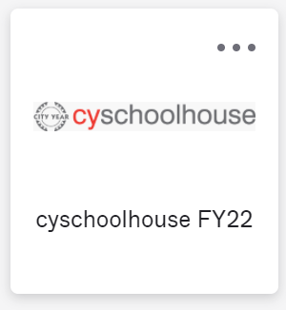

1. Select the section you want to enter time for

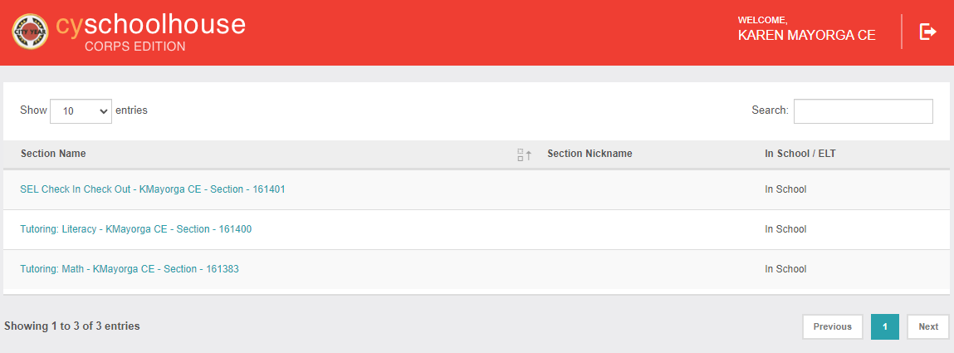

1. Select the students that correspond to the session you want to backlog by clicking the checkbox by their name and then click + Add Time at the top right-hand corner

1. Enter the Session date, use the drop-down menu to select ‘In-Person’ service, select a comment code option from the Site Details drop-down menu, select a primary Skill and enter time spent with student in minutes. Then click Submit.
   1. *Note: You can add missing students to the session by clicking the Add button, you can also remove students from the session by clicking the Delete button, each student in your session must have the same date and comment code, but time in minutes can vary per student in the session. Session Type, Tutoring Model and Session Format can be left blank.

